All Dependencies we've currently have used is

1. Link : https://nodejs.org/en/

Description: Node.js is an open source cross-platform Javascript runtime environment

Initial Steps for instantiating/building the project to have React files

1. npm init react-app reactjs (Professor and TA do not need to do this as the dependencies and libraries are already implemented and installed in the project.)

To run the build process to create an executable version of the product.

1. Go to Link:https://github.com/HelianthusNS/Coen174
2. Then we have to download the project from Github, you can do this by pressing the green <> Code button on the github link and downloading the zip file.
3. After everything is downloaded, we can go into the the directory and then cd into the folder .\jamify\
4. In the folder type the command: npm start
5. Now it will say that you

Local: <http://localhost:3000>

On Your Network: <http://192.168.56.1:3000>

1. Now you can visit <http://localhost:3000> to check the build. This will be our first unit testing infrastructure and from seeing this our logo you can see that our smoke test verified that the testing infrastructure is working.



Figure 1: Our logo

* A link to the unit testing framework you're using

<https://github.com/HelianthusNS/jamify>

<https://github.com/HelianthusNS/jamify/blob/master/src/App.js>

* The source code of the first test you wrote

import logo from './logo.svg';

import './App.css';

function App() {

return (

<div className="App">

<header className="App-header">

<p> Jamify Testing </p>

<img src="https://i.imgur.com/upAgTQO.png"/> <a href="home.js"> Home </a>

<a href="home.js"> Home </a>

<img src={logo} className="App-logo" alt="logo" />

<p> Edit <code>src/App.js</code> and save to reload.</p>

<a

className="App-link"

href="https://reactjs.org"

target="_blank"

rel="noopener noreferrer">

Learn React

</a>

</header>

</div>

);

} export default App;

* A screenshot of, or copy-pasted text from, your dashboard / test report (showing that you've got at least one passing test). Most test runners will create a report for you that shows which tests are passing and failing automatically.

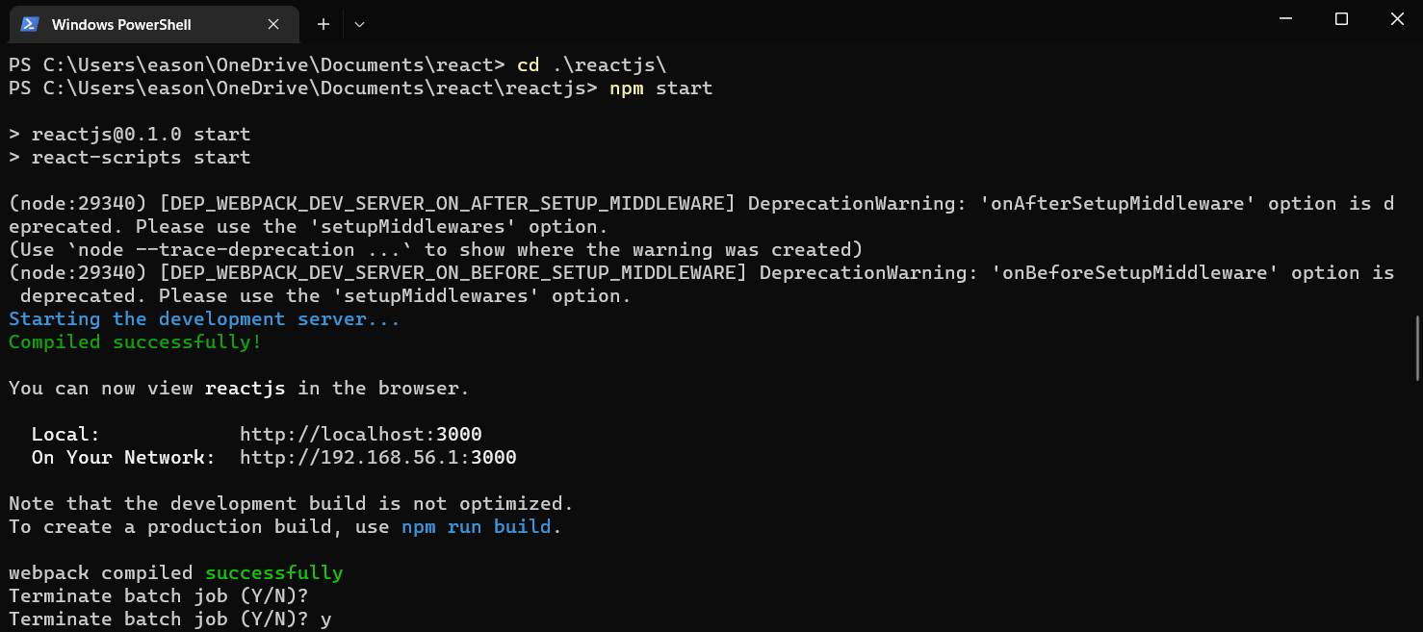

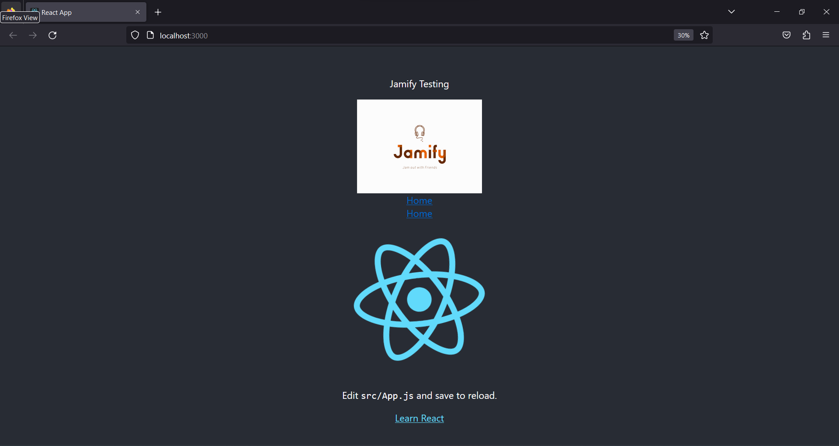

Notes_______________________________________________________________________

: npm and init are scripts in the package.json files.

To consistently create updates through branching:

Consult this link: <https://www.youtube.com/watch?v=e2IbNHi4uCI&ab_channel=freeCodeCamp.org>

____________________________________________________________________________

# Getting Started with Create React App

This project was bootstrapped with [Create React App](https://github.com/facebook/create-react-app).

## Available Scripts

In the project directory, you can run:

### `npm start`

Runs the app in the development mode.\

Open [http://localhost:3000](http://localhost:3000) to view it in your browser.

The page will reload when you make changes.\

You may also see any lint errors in the console.

### `npm test`

Launches the test runner in the interactive watch mode.\

See the section about [running tests](https://facebook.github.io/create-react-app/docs/running-tests) for more information.

### `npm run build`

Builds the app for production to the `build` folder.\

It correctly bundles React in production mode and optimizes the build for the best performance.

The build is minified and the filenames include the hashes.\

Your app is ready to be deployed!

See the section about [deployment](https://facebook.github.io/create-react-app/docs/deployment) for more information.

### `npm run eject`

**Note: this is a one-way operation. Once you `eject`, you can't go back!**

If you aren't satisfied with the build tool and configuration choices, you can `eject` at any time. This command will remove the single build dependency from your project.

Instead, it will copy all the configuration files and the transitive dependencies (webpack, Babel, ESLint, etc) right into your project so you have full control over them. All of the commands except `eject` will still work, but they will point to the copied scripts so you can tweak them. At this point you're on your own.

You don't have to ever use `eject`. The curated feature set is suitable for small and middle deployments, and you shouldn't feel obligated to use this feature. However we understand that this tool wouldn't be useful if you couldn't customize it when you are ready for it.

## Learn More

You can learn more in the [Create React App documentation](https://facebook.github.io/create-react-app/docs/getting-started).

To learn React, check out the [React documentation](https://reactjs.org/).

### Code Splitting

This section has moved here: [https://facebook.github.io/create-react-app/docs/code-splitting](https://facebook.github.io/create-react-app/docs/code-splitting)

### Analyzing the Bundle Size

This section has moved here: [https://facebook.github.io/create-react-app/docs/analyzing-the-bundle-size](https://facebook.github.io/create-react-app/docs/analyzing-the-bundle-size)

### Making a Progressive Web App

This section has moved here: [https://facebook.github.io/create-react-app/docs/making-a-progressive-web-app](https://facebook.github.io/create-react-app/docs/making-a-progressive-web-app)

### Advanced Configuration

This section has moved here: [https://facebook.github.io/create-react-app/docs/advanced-configuration](https://facebook.github.io/create-react-app/docs/advanced-configuration)

### Deployment

This section has moved here: [https://facebook.github.io/create-react-app/docs/deployment](https://facebook.github.io/create-react-app/docs/deployment)

### `npm run build` fails to minify

This section has moved here: [https://facebook.github.io/create-react-app/docs/troubleshooting#npm-run-build-fails-to-minify](https://facebook.github.io/create-react-app/docs/troubleshooting#npm-run-build-fails-to-minify)